The file in which the following commands are going to be executed:

1) Concat

2) Tokenize

3) Sum

4) Min

5) Max

6) Limit

7) Store

8) Distinct

9) Flatten

10) IsEmpty

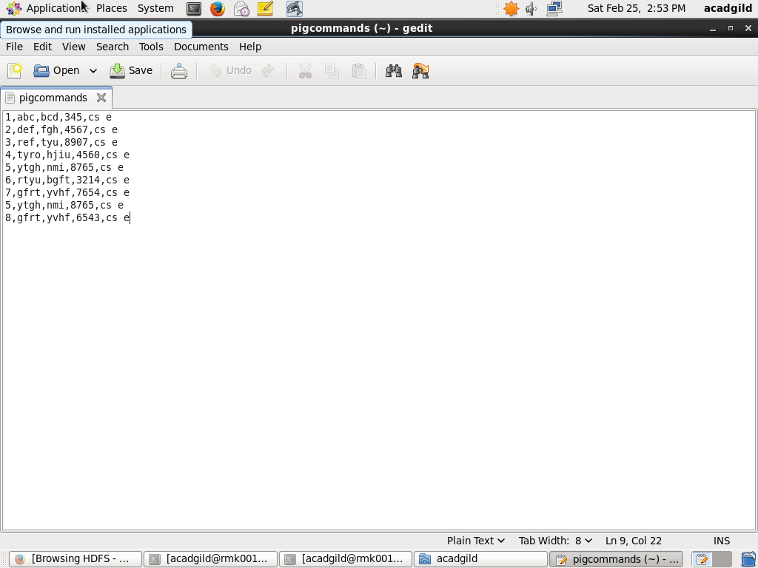

// LOAD THE RELATION: 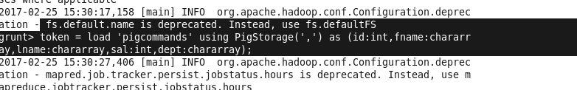

//DUMP THE RELATION:

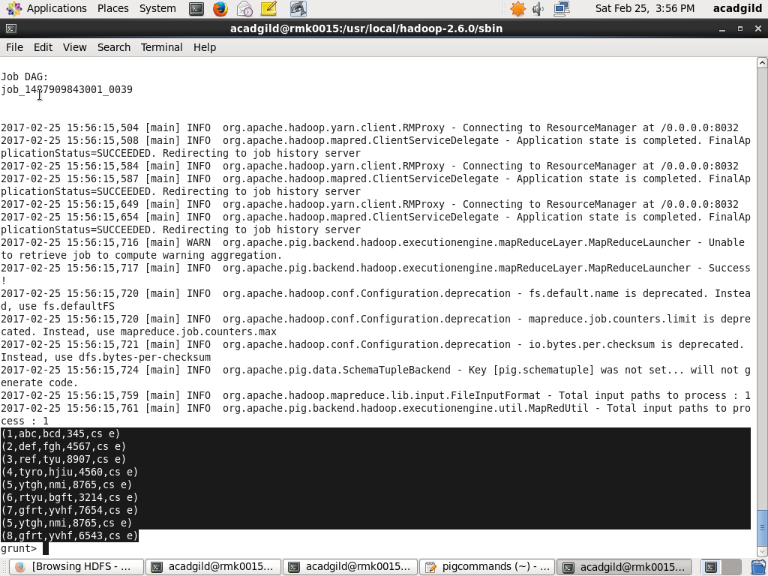

CONCAT COMMAND:

EXECUTION OF CONCAT :

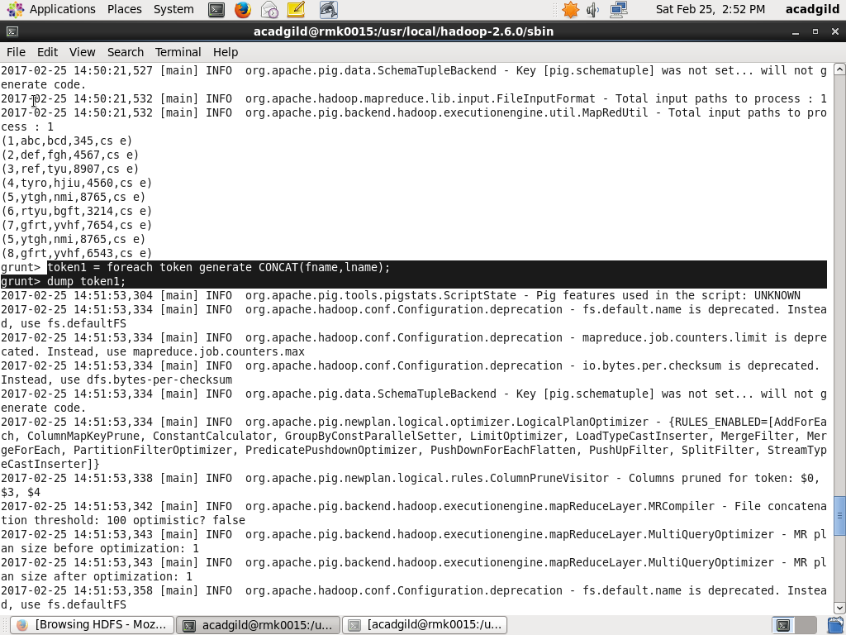

OUTPUT OF CONCAT COMMAND:

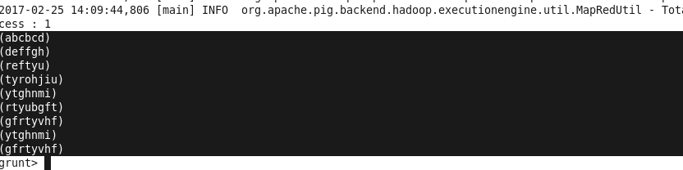

TOKENIZE COMMAND:

EXECUTION OF TOKENIZE COMMAND:

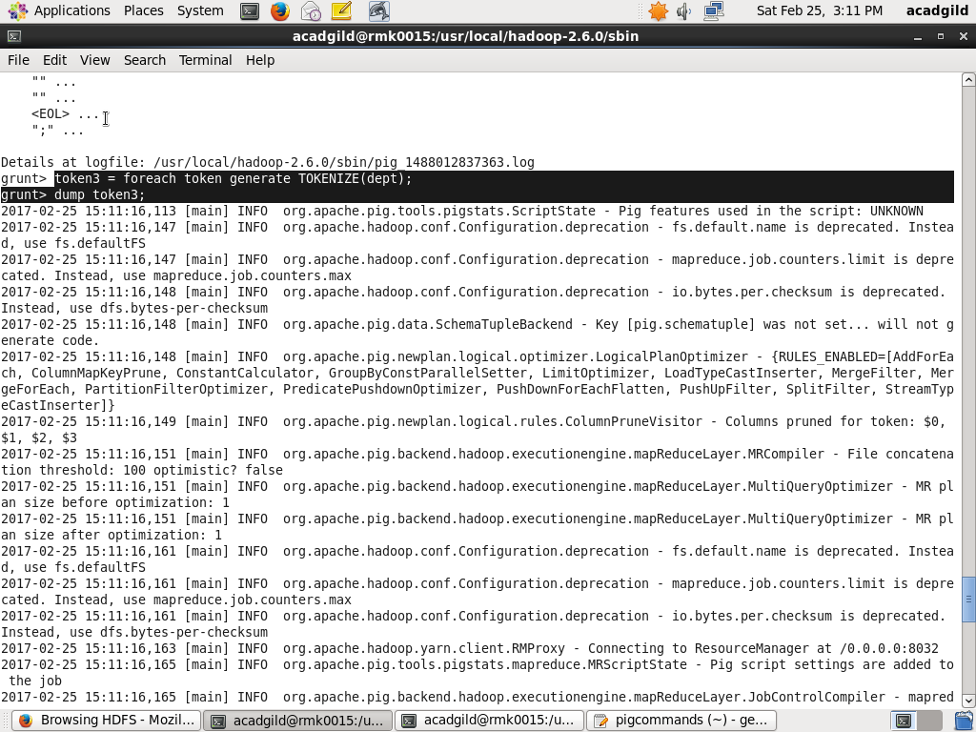

OUTPUT OF TOKENIZER COMMAND:

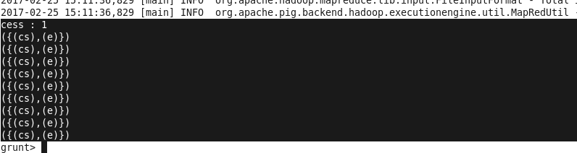

SUM COMMAND:

EXECUTION OF SUM COMMAND:

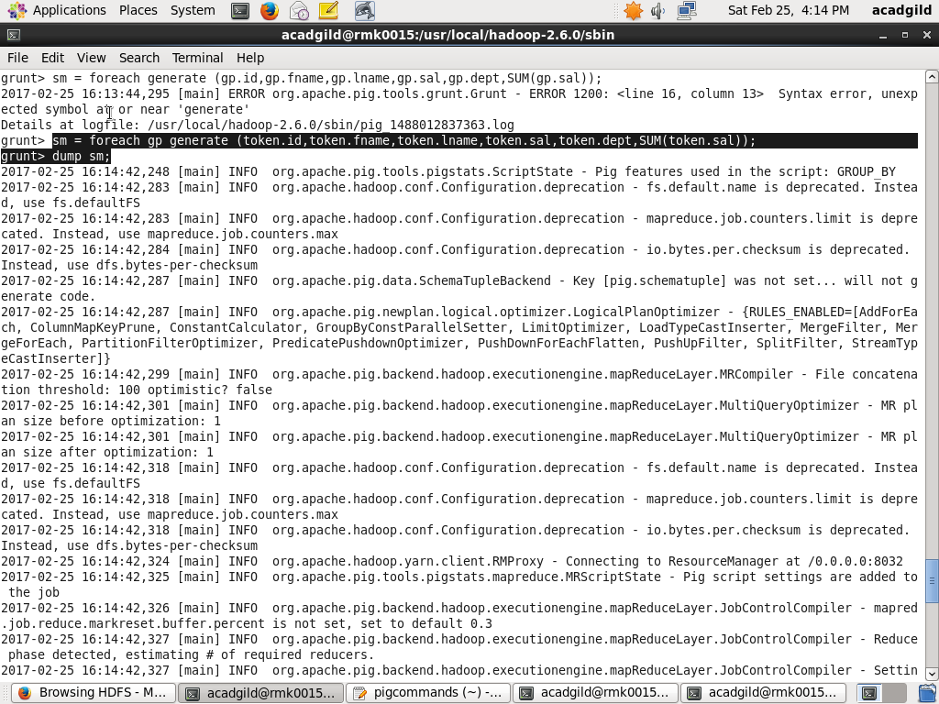

OUTPUT OF SUM COMMAND:



MIN COMMAND:

EXECUTION OF MIN COMMAND:

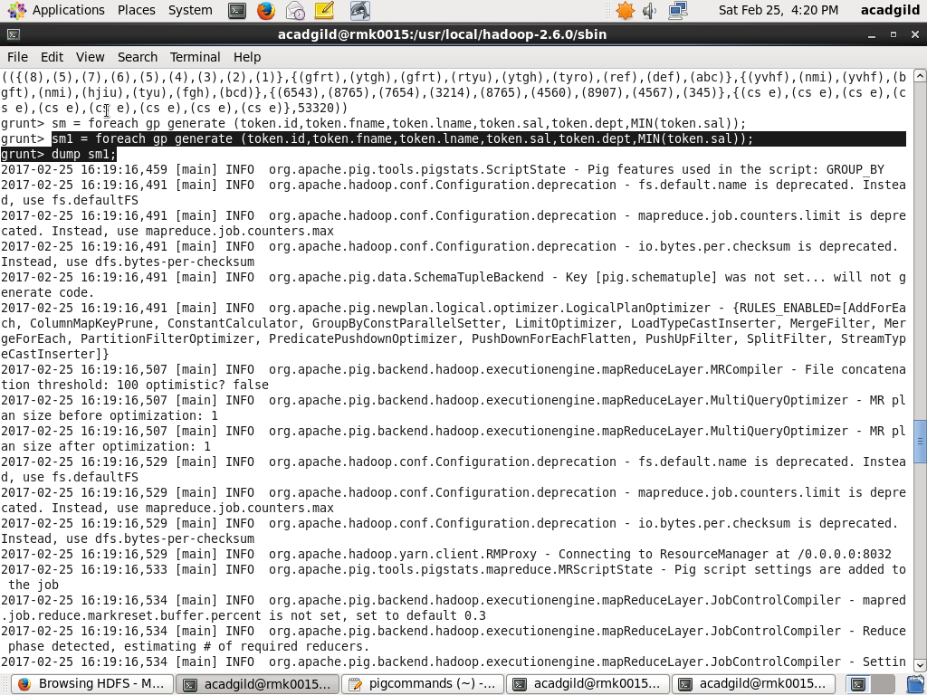

OUPUT OF MIN COMMAND:

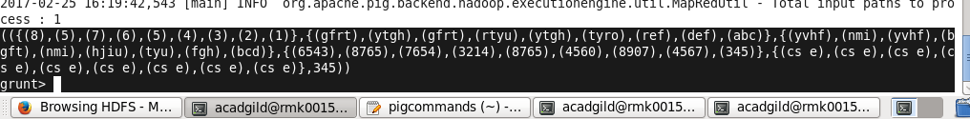

MAX COMMAND:

EXECUTION OF MAX COMMAND:

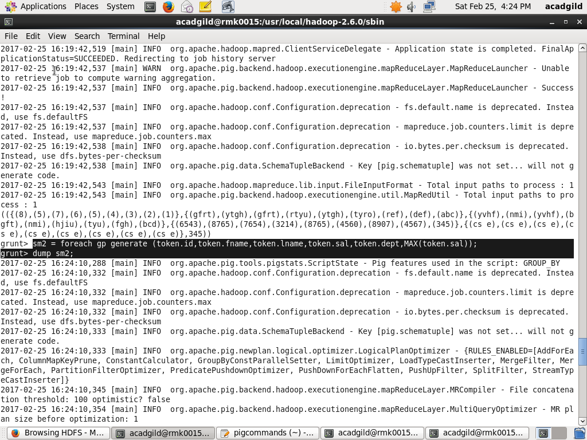

OUTPUT FOR MAX COMMAND:

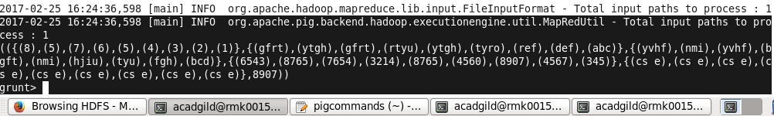

LIMIT COMMAND:

EXECUTION OF LIMIT COMMAND:

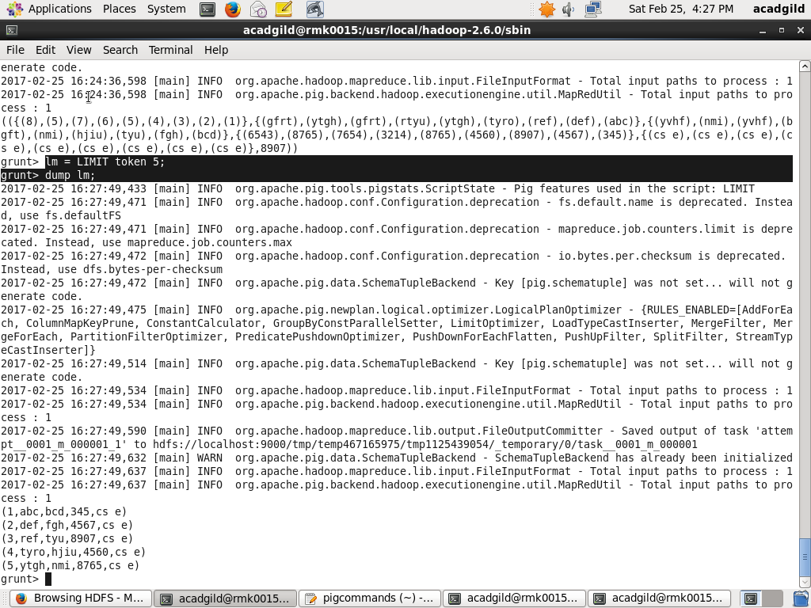

OUTPUT OF LIMIT COMMAND:

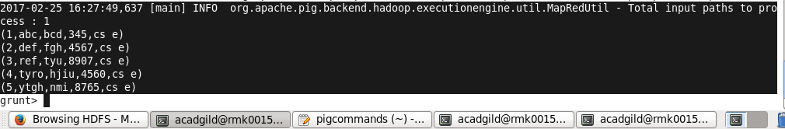

DISTINCT COMMAND:

EXECUTION OF DISTINCT COMMAND:

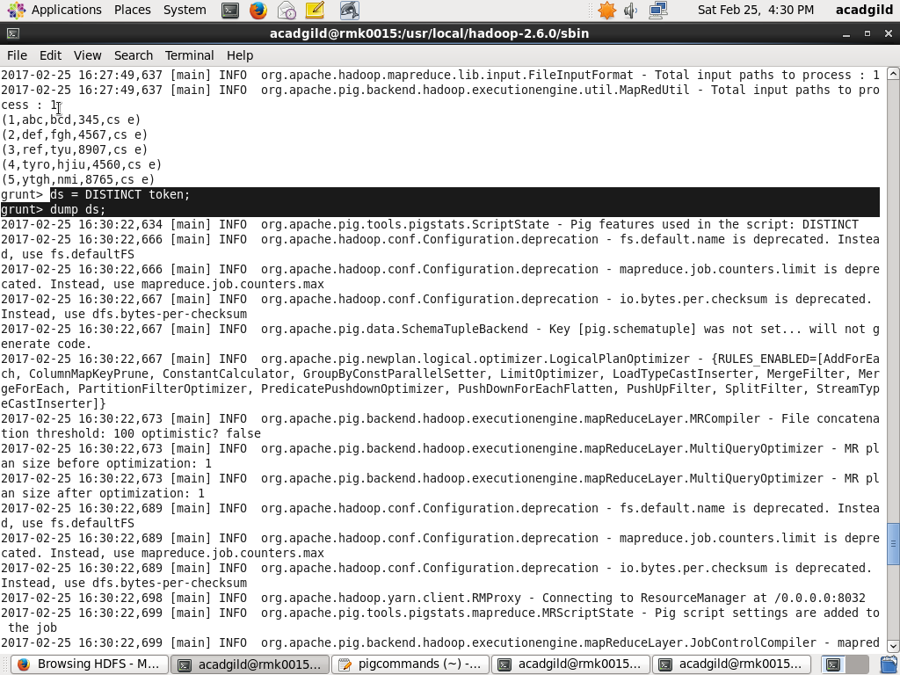

OUTPUT OF DISTINCT COMMAND:

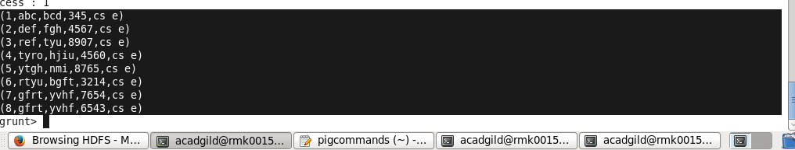

FLATTEN COMMAND:

//GROUP COMMAND

groupcr.png

//OUTPUT OF GROUP COMMAND:



EXECUTION OF FLATTEN COMMAND:



OUTPUT OF FLATTEN COMMAND:

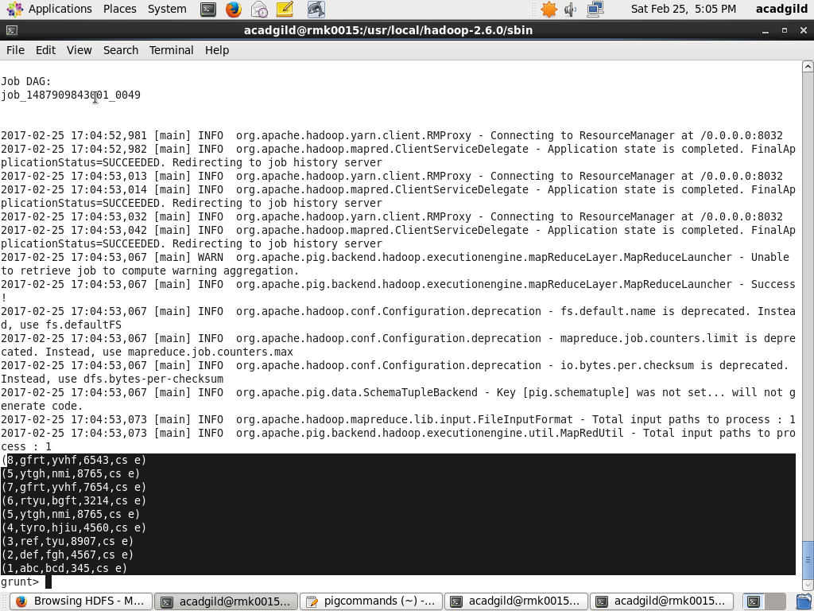

STORE COMMAND:

EXECUTION OF STORE COMMAND:

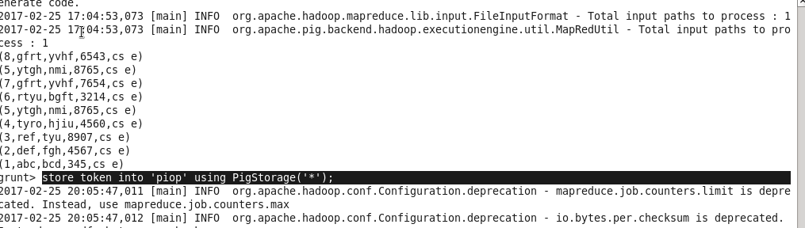

OUTPUT OF STORE COMMAND:

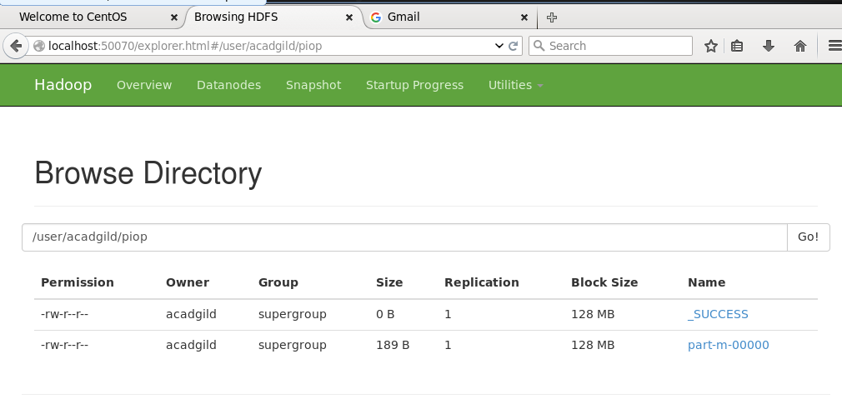

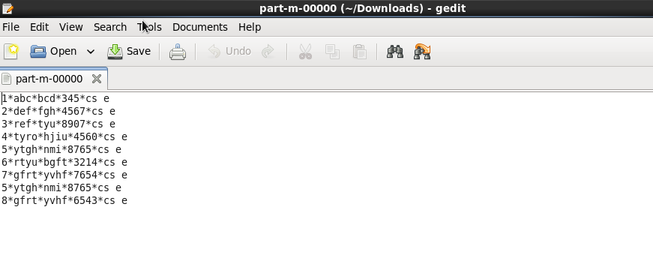

ISEMPTY COMMAND:

CONTENTS OF TOKEN:

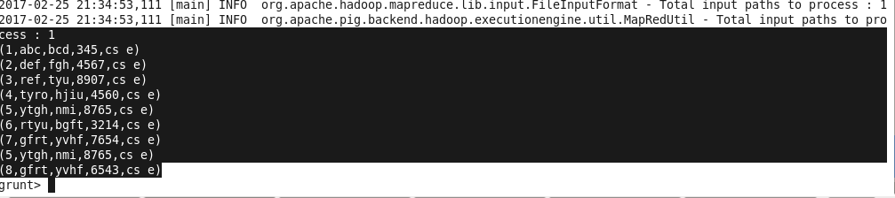

CONTENTS OF POST:

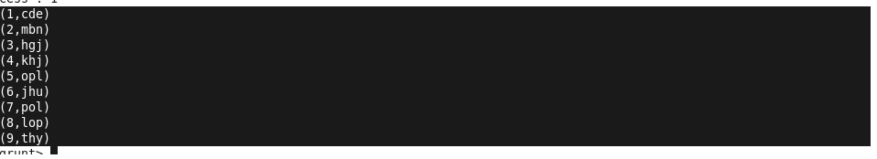

COGROUP OPERATION:

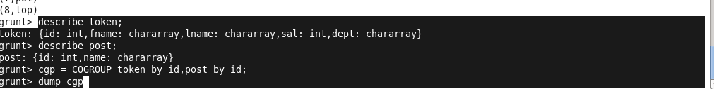

RESULT OF COGROUP:

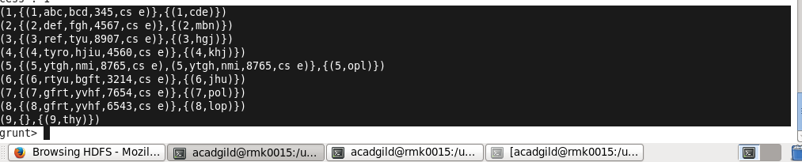

EXECUTION OF ISEMPTY COMMAND:



OUTPUT OF ISEMPTY COMMAND:

